CrackOnSurface:
If a CrackOnSurface expands, the expand is dependend of StrengthOfForce, the part of the IDestructible most likely to break out, the supportPolygon, and its place in relation to that supportPolygon. When expanding, the area of potential is calculated first. If another hole is in that area, they merge. After merging, some possible events could happen, that need to be checked (something broke out? Were the now merged holes part of the same cracks or from two different ones?). If there isn't another hole to merge with, a random point in the possible are is chosen, a new hole is generated there and becomes part of the expanding crack.
Each such step in Expanding reduces the Force and the process is repeated until the (force =< 0).

CrackInDepth:
Always expands away from the origin of force.
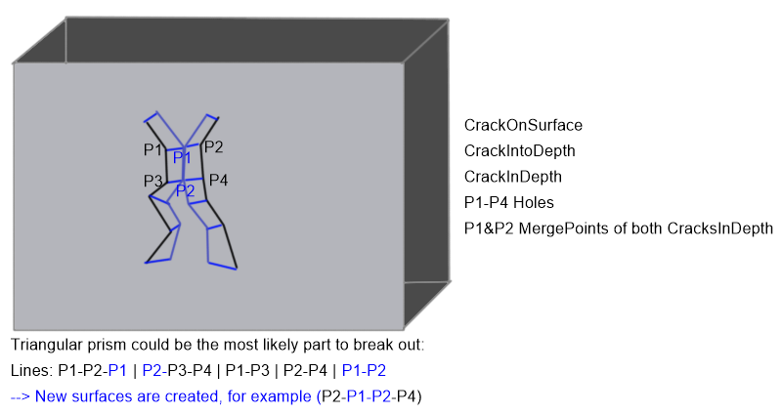
Special case, that could happen:
The Expansion of CracksInDepth happens similarily to the expansion of cracksOnSurface.

SupportPolygonCreator:
This class (or method?) calculates for every hit the area on the surface of the wall that is easiest to break out (2D-Level). It possibly also calculates the solids most likely to break out (3D-Level). It is to be seen, if the 2D-Level calculation gives a good enough approximation / if the 3D-Level calculation is too expensive.
Both those calculations make use of the Grid2D/Grid3D. For those calculations, outlines of the object are treated as Cracks.

ForceDistributer
Every Hit generates a force, that effects the IDestructible. Each of these effects reduces the original Force until its zero. Force can also be reduced without a lasting effect (for example on the outlines of the wall). Distribution will probably work like this:
Create SupportPolygon.
Create areaForceDistribution (for example: First k neighbouring Grids/Cubes receive 30 % of Force, next k neighbouring Grids/Cubes receive 20 %...). For each of those groups of Grids/Cubes, the Force is distributed between the Cracks those Grids/Cubes contain.
This distributions does not happen evenly but with prioritizing based on position in relation to the supportpolygon! Otherwise it could easily happen that no crack expands because Force/numberOfCracks is too low.

Alternatively: Instead of areas, the Forcedistributer gets the five smallest SupportPolygons, and the Force is distributed between them (for example most likely gets 30 percent of Force, second most likely gets 20 percent and so on...).

In both cases the Force is first distributed between different sets of cracks (areas or SupportPolygons) and in those sets distributed between the cracks and its holes.

